2.UNIFIED POWER FLOW CONTROLLER
2.1. Introduction
The UPFC is a combination of a static compensator and static series compensation. It acts as a shunt compensating and a phase shifting device simultaneously. The UPFC consists of a shunt and a series transformer, which are connected via two voltage source converters with a common dc-capacitor.
The dc-circuit allows the active power exchange between shunt and series transformer to control the phase shift of the series voltage, it provides the full controllability for voltage and power flow. The series converter needs to be protected with a thyristor bridge.
In section 2.2 discuss the operating principle of UPFC, in section 2.2.1 discuss the Var control mode, 2.2.2 explains the automatic voltage control mode, 2.2.3 discuss direct voltage injection mode, 2.3 discuss the UPFC circuit description, 2.4 discuss the operation of UPFC, 2.4.1 discuss operation of two converters, 2.4.2 discuss the equivalent circuit operation of UPFC, 2.4.3 discuss the UPFC power equations, 2.5 discuss the function of UPFC.
2.2. Operating Principle Of UPFC
The basic components of the UPFC are two Voltage Source Inverters (VSI’s) sharing a common dc storage capacitor and connected to the power system through coupling transformers. One VSI’s is connected to in shunt to the transmission system via a shunt transformer, while the other one is connected in series through a series transformer.
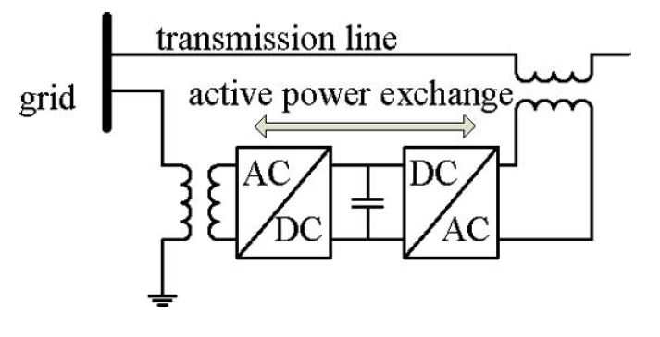
Fig.2.1. A basic UPFC functional scheme
The series inverter is controlled to inject a symmetrical three phase voltage system, of controllable magnitude and phase angle in series with the line to control active and reactive power flows on the transmission line. So, this inverter will exchange active and reactive power with the line. The reactive power is electronically provided by the series inverter, and the active power is transmitted to the dc terminals.
The shunt inverter is operated in such a way as to demand this dc terminal power from the line keeping the voltage across the storage capacitor V_{dc} constant. So, the net real power absorbed from the line by the UPFC is equal only to the losses of the inverters and their transformers. The remaining capacity of the shunt inverter can be used to exchange reactive power with the line so to provide a voltage regulation at the connection point.
The two VSI’s can work independently of each other by separating the dc side. So in that case, the shunt inverter is operating as a STATCOM that generates or absorbs reactive power to regulate the voltage magnitude at the connection point. Instead, the series inverter is operating as SSSC that generates or absorbs reactive power to regulate the current flow, and hence the power low on the transmission line.
The UPFC has many possible operating modes. In particular, the shunt inverter is operating in such a way to inject a controllable current, ash into the transmission line. The shunt inverter can be controlled in two different modes.
2.2.1. VAR Control Mode
The reference input is an inductive or capacitive VAR request. The shunt inverter control translates the VAR reference into a corresponding shunt current request and adjusts gating of the inverter to establish the desired current. For this mode of control a feedback signal representing the dc bus voltage, V_{dc} is also required.
2.2.2. Automatic Voltage Control Mode
The shunt inverter reactive current is automatically regulated to maintain the transmission line voltage at the point of connection to a reference value. For this mode of control, voltage feedback signals are obtained from the sending end bus feeding the shunt coupling transformer.
The series inverter controls the magnitude and angle of the voltage injected in series with the line to influence the power flow on the line. The actual value of the injected voltage can be obtained in several ways.
2.2.3. Direct Voltage Injection Mode
The reference inputs are directly the magnitude and phase angle of the series voltage. Phase angle shifter emulation mode. The reference input is phase displacement between the sending end voltage and the receiving end voltage.
Line impedance emulation mode, the reference input is an impedance value to insert in series with the line impedance. Automatic power flow control mode, the reference inputs are values of p and q to maintain on the transmission line despite system changes.

2.3. UPFC Circuit Description
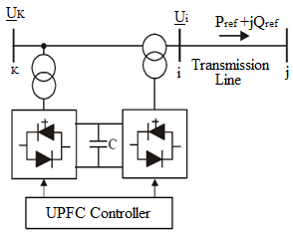
Fig. 2.2. Unified Power Flow Controller
The above figure gives a clear description about how UPFC controller connected to a transmission line. It consists of two back-to-back self-commutated voltage source converters, one converter at the sending end is connected in shunt as shunt converter and the other converter connected in between sending and receiving end bus in series as series converter.
One end of the both the converters are connected to a power system through an appropriate transformer and other end connected with a common DC capacitor link.
2.4. Operation Of UPFC
This arrangement of UPFC ideally works as an ideal ac to dc power converter in which real power can freely flow in either direction between ac terminals of the two converters and each converter can independently generate or absorb reactive power at its own AC output terminal.
The main functionality of UPFC provided by shunt converter by injecting an ac voltage considered as a synchronous ac voltage source with controllable phase angle and magnitude in series with the line.
The transmission line current flowing through this voltage source results in real and reactive power exchange between it and the AC transmission system. The inverter converts the real power exchanged at ac terminals into dc power which appears at the dc link as positive or negative real power demand.
2.4.1. Operation Of Two Converters
The operation for UPFC consists of two converters. They are
A. Series converter
B. Shunt converter
A. Series Converter Operation
In the series converter, the voltage injected can be determined in different modes of operation: direct voltage injection mode, phase angle shift emulation mode, Line impedance emulation mode and automatic power flow control mode. Although there are different operating modes to obtain the voltage, usually the series converter operates in automatic power flow control mode where the reference input values of P and Q maintain on the transmission line despite the system changes.
B. Shunt Converter Operation
The shunt converter operated in such a way to demand the dc terminal power from the line keeping the voltage across the storage capacitor V_{dc} constant. Shunt converter operates in two modes.
VAR Control mode and Automatic Voltage Control mode. Typically, Shunt converter in UPFC operates in Automatic voltage control mode.
The transmission line current flowing through this voltage source results in real and reactive power exchange between it and the AC transmission system.

2.4.2. Equivalent Circuit Operation Of UPFC
The two-voltage source converters of UPFC can model as two ideal voltage sources one connected in series and other in shunt between the two buses. The output of series voltage magnitude 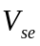 controlled between the limits 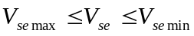 and the angle 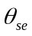 between the limits 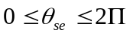 respectively.
The shunt voltage magnitude 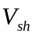 controlled between the limits 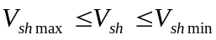 and the angle between 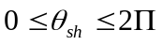 respectively. 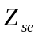 and 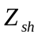 are considered as the impedances of the two transformers one connected in series and other in shunt between the transmission line and the UPFC as shown in the Fig 2.3 which is the UPFC equivalent circuit.
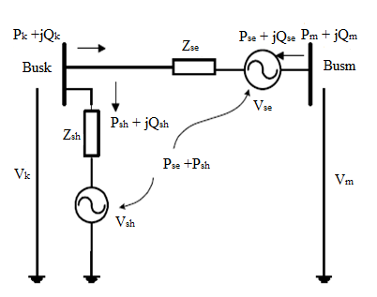
Fig. 2.3. Equivalent circuit of UPFC
The ideal series and voltage source from the Fig 2.3 can written as
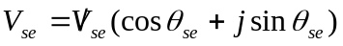 .… (2.1)
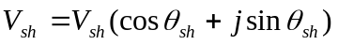 …. (2.2)
The magnitude and the angle of the converter output voltage used to control the power flow mode and voltage at the nodes as follows
1) The bus voltage magnitude can be controlled by the injected a series voltage in phase or anti-phase.
2) Power flow as a series reactive compensation controlled by injecting a series voltage 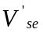 in quadrature to the line current.
3) Power flow as phase shifter controlled by injecting a series voltage of magnitude 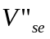 in quadrature to node voltage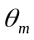.
2.4.3. UPFC power Equations
Based on the equivalent circuit as shown in Fig 2.3, the active and reactive power equations can be written as follows
At node k:
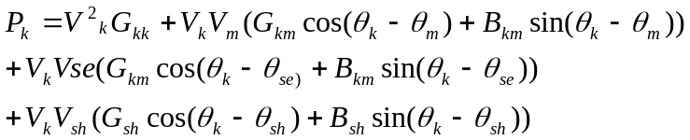 … (2.3)
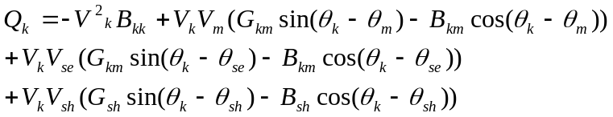 … (2.4)
At node m:
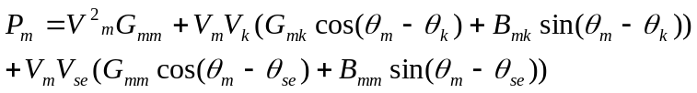 … (2.5)
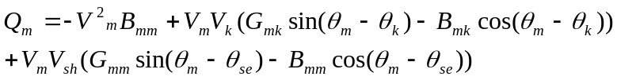 … (2.6)
Series converter:
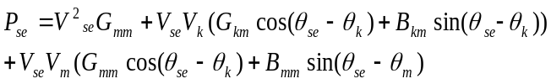 … (2.7)
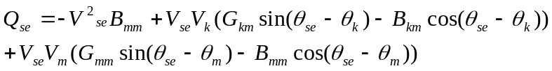
Shunt converter:
… (2.8)
… (2.9)
Where
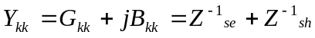 ... (2.10)
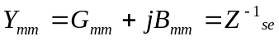 … (2.11)
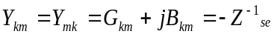 … (2.12)
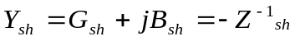 … (2.13)
Assuming a free converter loss operation, the active power supplied to the shunt converter 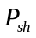 equals to the active power demanded by the series converter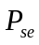.
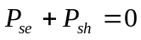 … (2.14)
Furthermore if the coupling transformers are assumed to contain no resistance then the active power at bus k matches the active power at bus m that is,
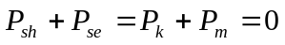 … (2.15)
The UPFC power equations linearised and combined with the equations of the AC transmission network. For the cases when the UPFC controls the following parameters
1) Voltage magnitude at the shunt converter terminal.
2) Active power flow from bus m to bus k.
3) Reactive power injected at bus m, and taking bus m to be PQ bus.
2.5. Function Of UPFC
The operation of the UPFC from the standpoint of conventional power transmission is based on reactive shunt compensation, series compensation, and phase shifting. The UPFC can fulfill these functions and thereby meet multiple control objectives by adding the injected voltage VSE, with appropriate amplitude and phase angle.
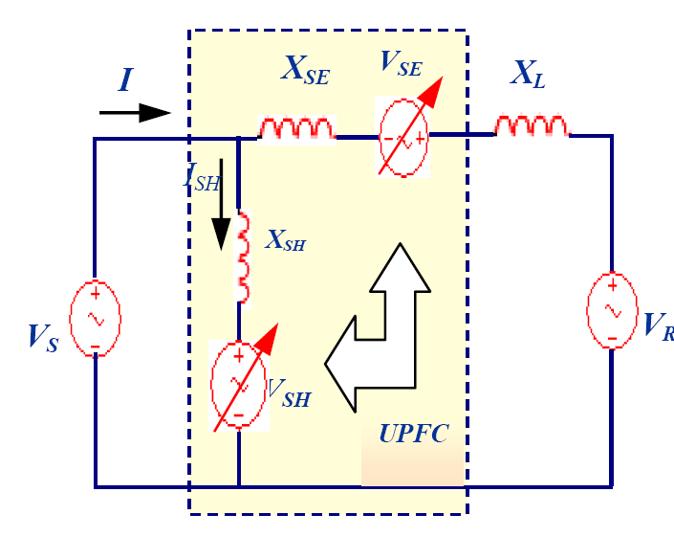
Fig.2.4. UPFC schematic diagram

A. Uncompensated Simple Power System
A simple two machine system connected through a transmission line whose reactance is x_{L} with its voltages phasor shown in Fig. 2.5 (a) and (b) The equation of power transfer is given as follows
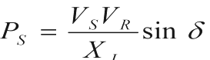 … (2.16)
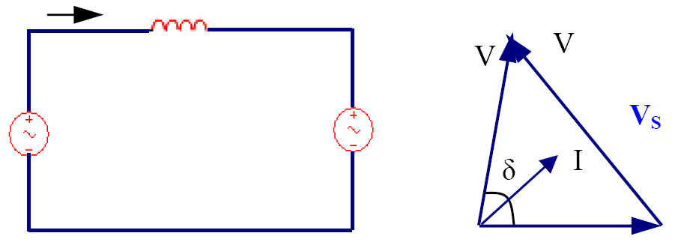
(a) (b)
Fig.2.5. Uncompensated system (a) Circuit (b) Voltage Phasor
B. Shunt Converter Operation
The shunt branch is represented as a variable voltage source V_{SH} with variable magnitude and phase angle and connected to the sending end by a reactance X_{SH} as shown in Fig. 2.6 (a). With no series compensation, the function of the shunt branch is to regulate the line voltage by injecting a shunt reactive current into the transmission line.
The compensation type inductive or capacitive is depending on whether the shunt voltage source V_{SH} is higher or lower than the sending end voltage VS as.
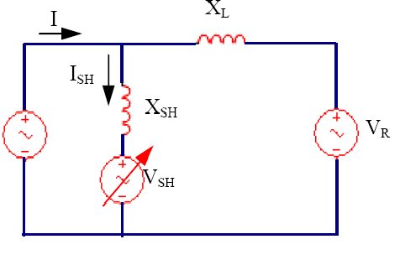

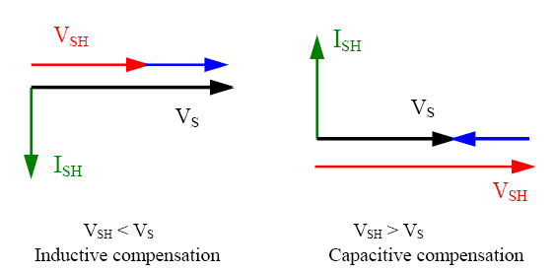

Fig.2.6. Shunt compensation
C. Series Converter Operation
The series branch provides the main function of the UPFC by controlling the three parameters affect the power flow in a transmission line simultaneously and independently.
It is represented by a series AC variable voltage source with controllable magnitude V_{SE} and phase angle α measured from the reference voltage V_{R} and connected to the sending end by a reactance XSE.
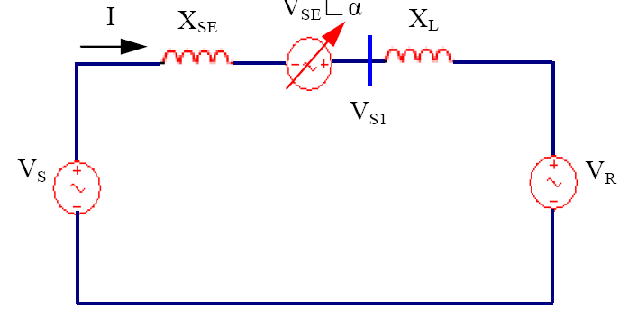
Fig.2.7. Series branch schematic diagram
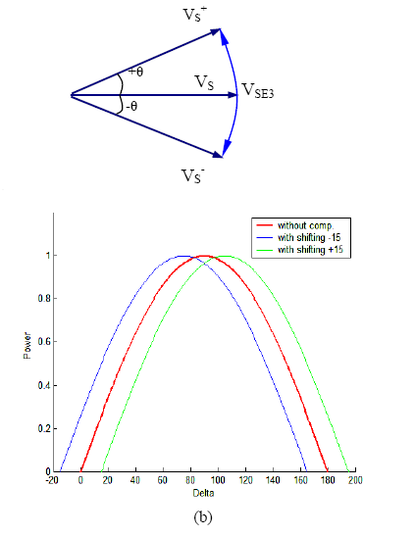
Fig.2.8. Phase angle compensation (a) Phasor diagram (b) p-∆ curves
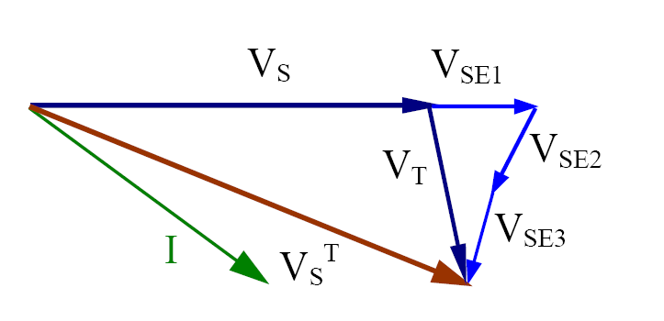
Fig.2.9. Combined compensation phasor diagram
The series converter has the following four operation modes

• Voltage Regulation
It is considered as a terminal voltage regulator similar to that obtainable with a transformer tap-changer having infinitely small steps. When the series voltage V_{SE} is injected in-phase or out-of-phase.
• Series Reactive Compensation
It is used to control the current or power flow by regulating the transmission line’s effective reactance by connecting the series voltage V_{SE} in quadrature with the line current.
Where the series voltage V_{SE} may be replaced by a reactance X_{CSE} (0 ≤ X_{CSE} ≤ X).
• Phase Angle Compensation
This is used for regulating the phase angle of the line voltage by a series connected compensating voltage VSE, in quadrature with respect to the voltage, keeping the voltage amplitude of the sending-end nearly constant.
2.6. Summary
In this chapter, unified power flow controller is used to control the active and reactive power in the transmission line. But it consists some disadvantages when compared to distributed power flow controller. Disadvantages like, it requires more space and high isolation due to high voltage rating.

